Application of Machine Learning Methods to Real-World Data
Methodological Approach
The primary objective of this project was to classify discrete human activities from raw, multivariate accelerometer data. Because human kinematics are inherently noisy and highly individualised, we designed the methodological framework to systematically evaluate multiple, progressively complex learning paradigms, ranging from automated representation learning to deterministic, physics-informed feature engineering.
The Generalisation and Validation Strategy
A critical priority in this methodology was ensuring the final model could generalise to novel individuals rather than memorising the specific biomechanical quirks of the training cohort. To rigorously simulate the unseen Kaggle holdout environment, we integrated GroupKFold cross-validation strategies across all experimental pipelines, with data partitioned explicitly by user_id.
Our methodology followed three distinct phases:
- Establishing linear baselines on raw waveforms.
- Exploring spatial representation learning via 1D-CNNs.
- Engineering a deterministic, heavily regularised XGBoost architecture.
The rigorous evaluation of these models is detailed in the ML Modelling section.
Exploratory Data Analysis
Dataset Overview and Structural Properties
The dataset provided comprises multivariate time-series accelerometer readings collected from 36 unique individuals. To evaluate model generalisation, the cohort was partitioned into a training set of 28 subjects and a completely unseen holdout set of 8 subjects for the final Kaggle leaderboard evaluation. The presence of these unseen individuals in the final test set meant we had to use GroupKFold cross-validation during the modelling phase to prevent overfitting to the specific biomechanical traits of the training subjects.
The sensors operated at a fixed sampling frequency of 20 Hz, and the continuous data stream was pre-segmented into discrete 5-second temporal windows. This 5-second window provides a tight temporal boundary that prevents the blurring of distinct, consecutive physical actions. This dictates the precise dimensional shape of the raw input: a 20 Hz, 5-second window gives 100 chronological observations per axis. Consequently, each user_snippet is initially represented by a 300-dimensional continuous matrix (100 readings x 3 axes).
Parameter | Specification | Implication
User Cohort | 36 total subjects:  - 28 training subjects  - 8 unseen subjects | The holdout set mandates GroupKFold cross-validation to prevent the model from overfitting.
Sampling Frequency | 20 Hz | 20 discrete acceleration readings captured per second.
Window Size | 5 Seconds | A tight temporal boundary that isolates distinct physical actions.
Samples per Snippet | 100 | 20 Hz x 5 seconds = 100 continuous data points per axis.
Input Dimensions | 3 Axes (x, y, z) | The raw matrix shape per snippet is exactly 100 x 3.

Target Distribution and Class Imbalance
The target variable is a multiclass categorical label mapping each snippet to one of six physical activities. An initial exploration of the training metadata revealed a severe class imbalance.
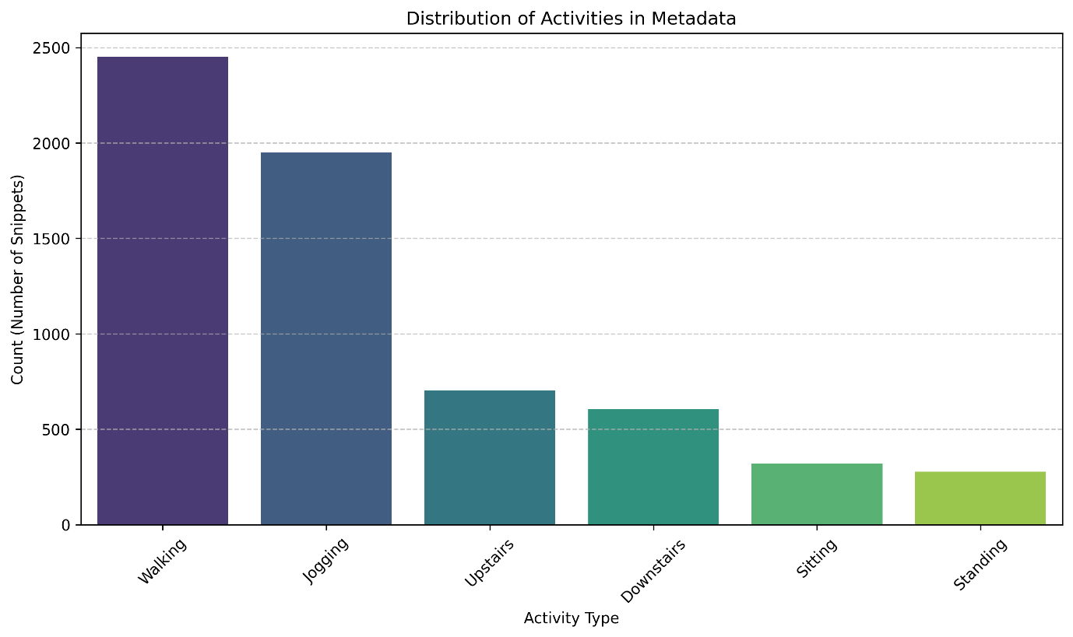
Figure 1: Distribution of target classes within the training dataset, highlighting the severe underrepresentation of stationary activities.
As shown in Figure 1, dynamic activities heavily dominated the dataset. Walking (3220) and Jogging (2640) accounted for over 71.1% of the total training data. Conversely, stationary activities were critically underrepresented, with Sitting (343) and Standing (321) making up less than 8.1% combined. This imbalance presents a significant modelling challenge, requiring a robust, highly regularised algorithm capable of learning the minority classes without becoming inherently biased toward predicting the majority classes.
Raw Signal Analysis and Class Overlap
To understand the biomechanical profiles of the target classes, we visually inspected the raw x, y and z waveforms. This analysis revealed distinct overlap between certain activities, demonstrating why raw wave data alone is insufficient for high-accuracy classification and why complex feature engineering is required.
Sitting vs Standing
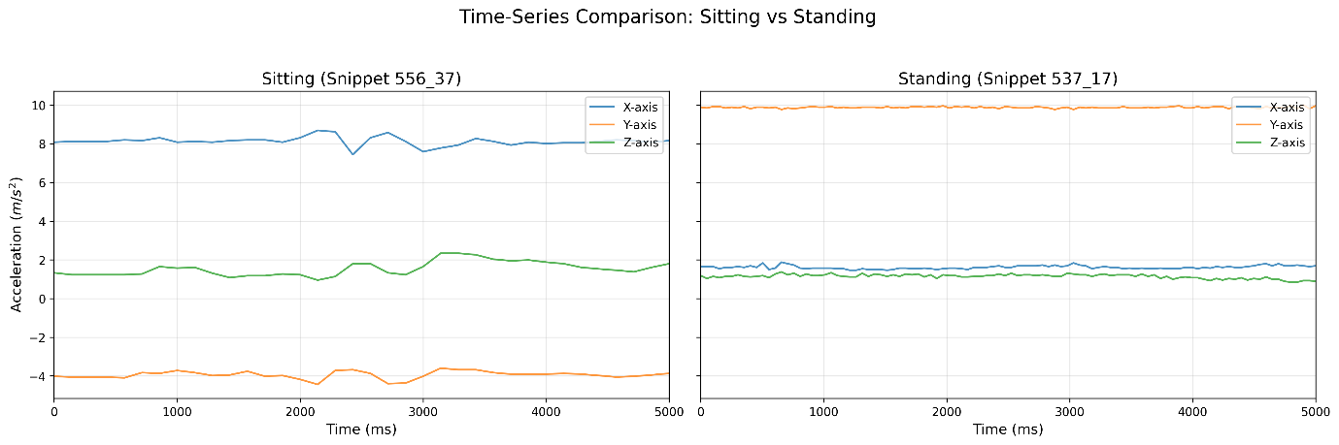
Figure 2: Raw acceleration waveforms comparing Sitting and Standing. Both activities exhibit near-zero variance on all axes, making them virtually indistinguishable without spatial orientation context.
Figure 2 illustrates the primary challenge with stationary activities. Because the user is not generating kinetic force, the accelerometer primarily registers only the constant pull of the Earth’s gravity (9.8m/s²). Both “Sitting” and “Standing” present as flat, noiseless lines. To separate these classes, the model cannot rely on wave shape or variance, it must rely on the precise spatial orientation (pitch and roll) of the device within the user’s pocket.
Walking vs Jogging
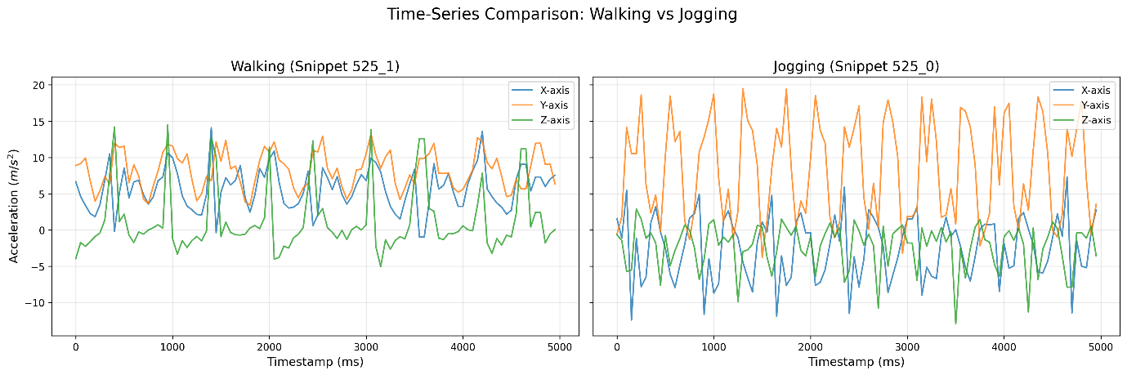
Figure 3: Waveform comparison of Walking and Jogging. The core rhythmic shape is identical, but Jogging exhibits a significantly higher amplitude due to increased impact force.
Figure 3 demonstrates that Walking and Jogging share a nearly identical harmonic frequency, representing a standard bipedal gait. The primary distinguishing factor in the raw data is the amplitude of the y-axis (vertical) wave, representing the harsher foot-strike impact of jogging.

Upstairs vs Downstairs
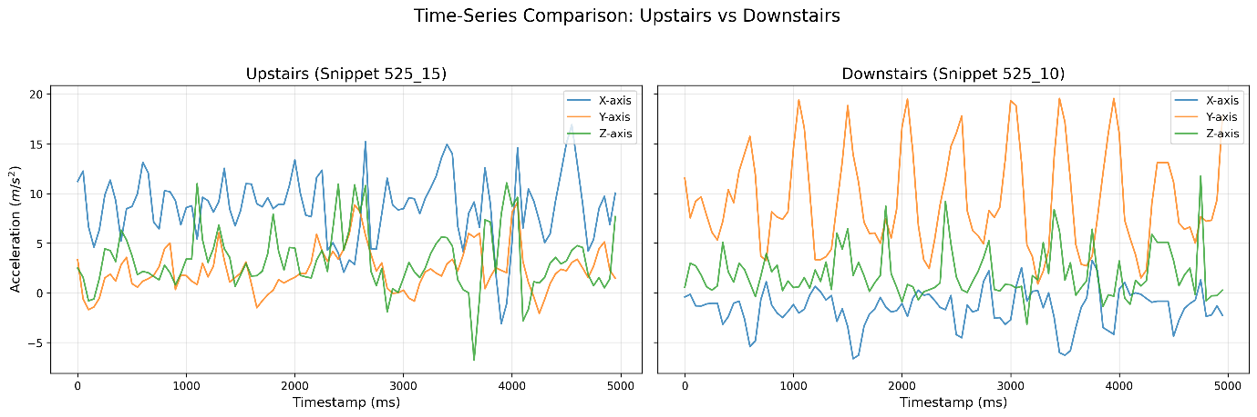
Figure 4: Waveform comparison of walking Upstairs and Downstairs. The waveforms are highly entangled, lacking clear visual distinctions in either amplitude or basic frequency.
The most difficult classification boundary exists between “Upstairs” and “Downstairs”. As shown in Figure 4, the raw time-series data for these activities is chaotic and highly overlapping. Both involve vertical displacement and similar foot-strike impacts. This specific visual entanglement ultimately proved the necessity of abandoning purely visual deep learning models (such as CNNs) in favour of extracting hard, discrete mathematical thresholds (such as Jerk derivatives and Spectral Centroids) to separate the classes in a high-dimensional tabular space.
Univariate Feature Separability and Variance
While raw waveform visualisation highlights the entanglement of kinetic classes, extracting univariate statistical features begins to reveal the underlying mathematical separability of the dataset. To demonstrate this, we calculated the variance of the y-axis (representing vertical displacement) across the entire training cohort and mapped to the target activities.
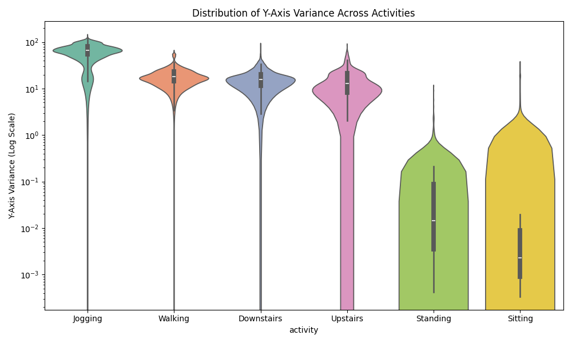
Figure 5: Violin plot demonstrating the distribution of y-axis variance across the six activities (logarithmic scale).
As illustrated in the violin plot (Figure 5), transitioning from raw time-series data to aggregated statistical properties creates immediate, tangible boundaries. Stationary activities (Sitting, Standing) exhibit a variance converging near zero, presenting as a highly dense, flat distribution. Standard motion (Walking, Upstairs, Downstairs) forms a distinct, middle-tier cluster, while Jogging isolates itself entirely in the upper quartile of the logarithmic scale due to its high-impact foot-strike. However, the distinct overlap in the interquartile ranges of Walking, Upstairs and Downstairs further reinforces the hypothesis that single-variable thresholds are insufficient, and a high-dimensional feature matrix will be required for the final classification.
Cross Axis Correlation and Spatial Dependencies
A secondary finding during the exploratory phase was the presence of strong intra-snippet spatial dependencies. Human movement is rarely isolated to a single directional vector, a forward stride (x/z axes) naturally generates a vertical bounce (y axis).
By calculating the Pearson correlation coefficient between the x, y and z axes for each 5-second snippet, we observed that dynamic activities exhibit highly specific synchronous patterns. For example, during a standard walking gait cycle, the horizontal and vertical accelerations maintain a rhythmic, phase-locked correlation. Conversely, anomalous or transitional movements display chaotic cross-axis correlations. This insight made us include multi-axial correlation metrics (such as Signal Magnitude Vectors: √(x²+y²+z²)) into the final feature engineering pipeline, ensuring the model captured the holistic 3D posture of the device rather than treating each axis in a vacuum.
Harmonic Profiling: The Frequency Domain (FFT)
The final, and arguably most critical, exploratory investigation involved transforming the data from the temporal domain into the frequency domain. Because activities like Walking and Jogging represent cyclical, repeating biomechanical processes, viewing their waveforms purely sequentially (over time) obscures their fundamental rhythms.
To uncover these rhythms, we applied a discrete Fast Fourier Transform (FFT) to the acceleration signals, decomposing the complex waves into their sine and cosine frequencies.
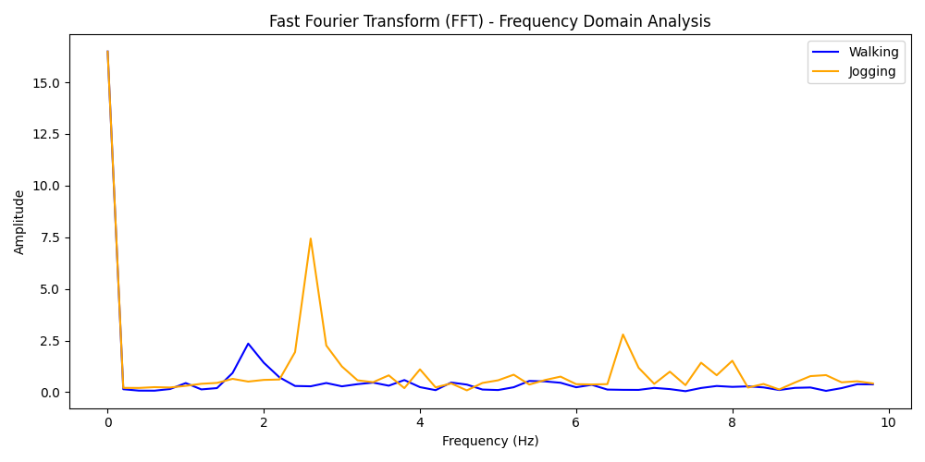
Figure 6: Power Spectral Density mapping via Fast Fourier Transform.
Figure 6 demonstrates the profound diagnostic power of the frequency domain. While Walking and Jogging look visually similar in the raw time domain (differing only in amplitude), the FFT plot reveals strictly distinct rhythmic fingerprints. The dominant peaks in the spectrum correspond precisely to the user’s step cadence (steps per second). By extracting specific spectral features such as the Spectral Centroid (the “centre of mass” of the frequencies) and the peak harmonic frequencies, we can mathematically isolate the rhythmic speed of the subject. This specific exploratory insight led to the engineering of the y_spec_centroid feature, which ultimately proved to be the single most important predictive variable in the final XGBoost architecture.
ML Modelling
To establish a robust predictive pipeline, we conducted the modelling phase sequentially. The investigation systematically transitioned from establishing baseline dynamics across diverse algorithm families, to evaluating spatial pattern recognition via Deep Learning, and ultimately engineering a highly regularised gradient-boosting architecture.
Baseline Benchmarking across Algorithm Families
We performed initial benchmarking using a preliminary set of 50 extracted metadata features to evaluate the dataset’s compatibility with different types of algorithms. We deployed a series of fundamental models, including K-Nearest Neighbours (KNN), Support Vector Machines (SVM), Logistic Regression, Decision Trees and Random Forest.
While these baseline models achieved high local cross-validation scores (e.g. SVM achieving an impressive 0.9533 validation CV), evaluating these models against unseen holdout data exposed a critical generalisation gap. Tree-based ensembles (Decision Trees, Random Forest) exhibited extreme variance. The default baseline Random Forest achieved a near-perfect Training CV of 0.9617, but its validation score collapsed to 0.7552, exposing severe high-variance overfitting. This severe drop indicated that unregularised algorithms were memorising the specific movement noise and hardware orientations of the training subjects, rather than mathematically abstracting the universal physics of human activity.
The Spatial Approach: Deep Learning (1D-CNN)
We decided to train a 1-Dimensional Convolutional Neural Network (utilising a ResNet backbone) directly on the raw, 300-dimensional continuous time-series arrays. The hypothesis was that multi-scale convolutional filters could autonomously learn the spatial and temporal hierarchies of the waveforms. To prevent network overconfidence, we integrated MixUp data augmentation to synthesise intermediate wave states and smooth the Softmax decision boundaries.
The CNN achieved the highest local metrics of any model tested, recording a Mean Validation F1-score of 0.9832 (95% CI: [0.9747, 0.9917]). However, evaluation on the Kaggle leaderboard resulted in a major drop in accuracy to ~0.907.
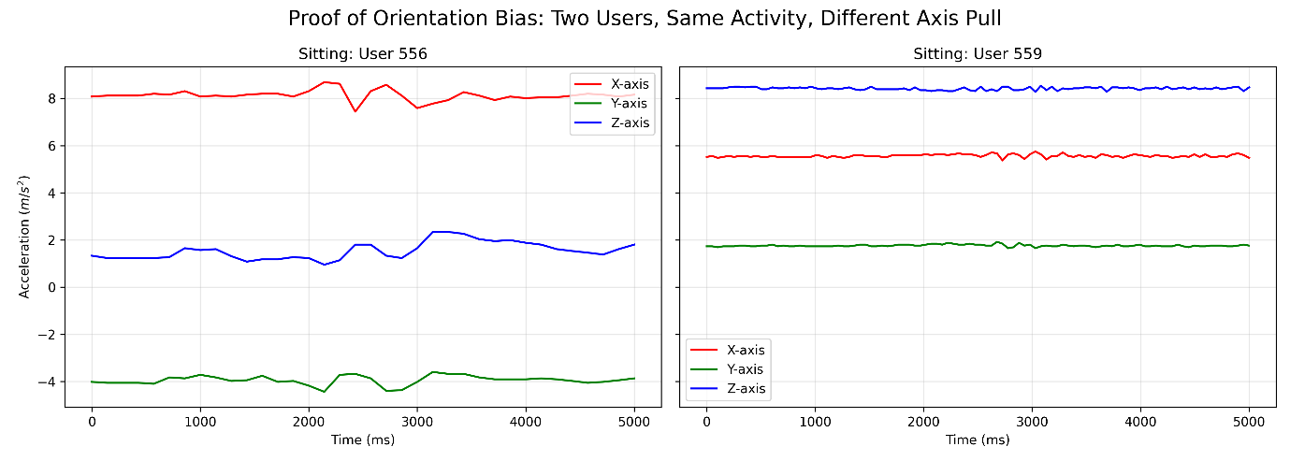
Figure 7: A visualisation of orientation bias, illustrating how inverted hardware orientations severely disrupt spatial deep learning architectures.
As visualised in Figure 7, the CNN has succumbed to orientation bias. Because convolutional networks process sequences spatially, an inverted phone in a user’s pocket artificially flips the waveforms. The network memorised the static gravitational pull on specific axes for the training subjects, failing to recognise identical physical movements captured from alternative hardware angles. This failure highlighted that for this specific dataset, rotation-invariant mathematical features are demonstrably superior to unanchored spatial deep learning.
Latent Space Evaluation (PCA vs. t-SNE)
Having established that automated Deep Learning was highly susceptible to orientation bias, we pivoted our methodology to advanced, deterministic feature engineering. We derived a high dimensional matrix of 140 physical variables (incorporating Jerk derivatives and Fourier transforms). However, before deploying complex predictive architectures, it was critical to visually validate if this new mathematical space actually separated the entangled physical activities using two distinct dimensionality reduction techniques.
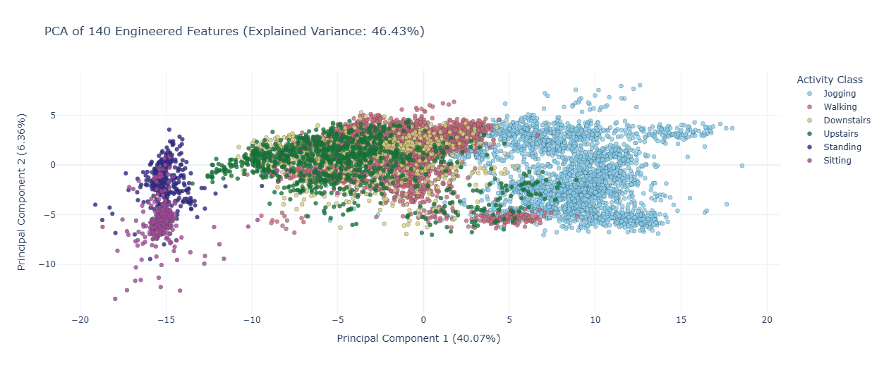
Figure 8: Principal Component Analysis (PCA) projection, attempting to linearly separate the 140-dimensional feature space.
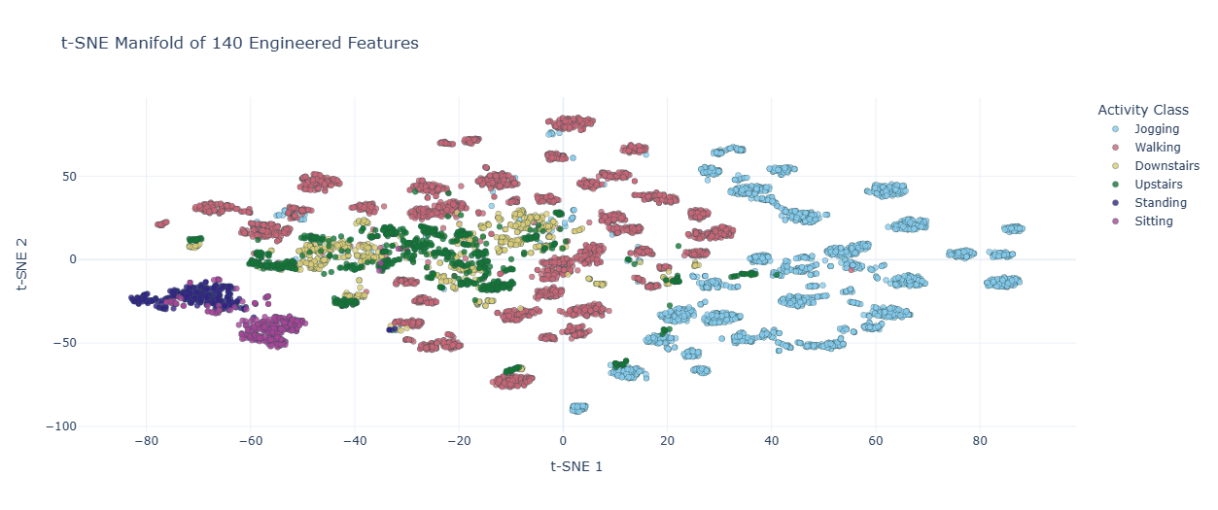
Figure 9: t-Distributed Stochastic Neighbour Embedding (t-SNE) mapping, demonstrating the preservation of non-linear local neighbourhoods.
The linear PCA (Figure 8) successfully separated stationary activities from dynamic ones along the axis of maximum variance but left highly complex movements (such as stairs) entirely entangled. Conversely, the t-SNE projection (Figure 9), which operates by minimising the Kullback-Liebler divergence between joint probabilities in high and low-dimensional spaces, successfully collapsed the 140 features into distinct, highly separable topographical clusters. This comparative visual analysis proved conclusively that the 140 features possessed the necessary predictive signal but strictly required a highly non-linear classifier to draw the final decision boundaries.
Comparative Learning Curve Diagnostics and Regularisation
While the t-SNE projection proved a non-linear tree model was required, the baseline benchmarking already demonstrated that standard tree ensembles (like Random Forest) suffer from extreme variance on this dataset. To diagnose this, we conducted a Learning Curve analysis. This diagnostic evaluated how the predictive capacity of different algorithms scaled in response to the volume of data ingested, plotting overall accuracy (y-axis) against the total number of training snippets provided (x-axis).
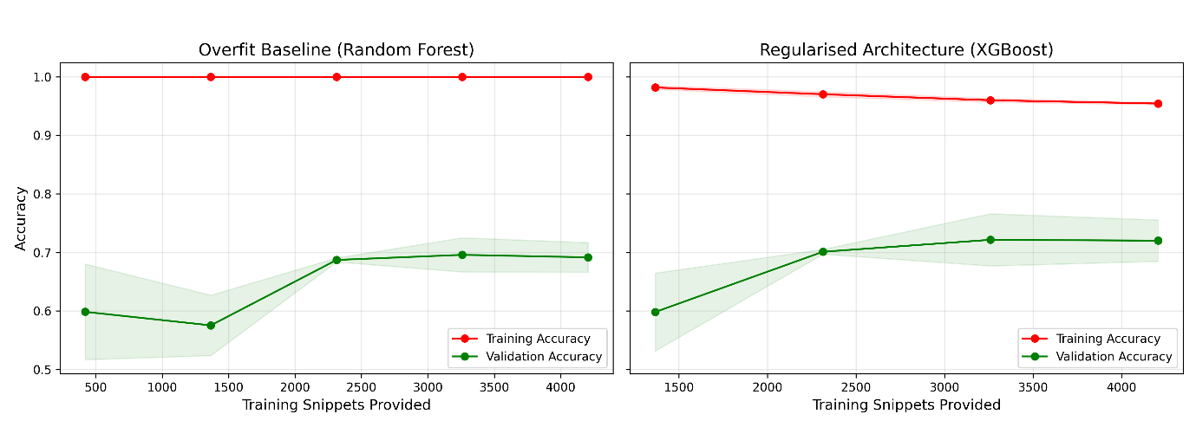
Figure 10: Comparative learning curve analysis.
As detailed in the Overfit Baseline plot, evaluating an unconstrained tree ensemble reveals a severe generalisation gap. Regardless of the number of training snippets provided, the model rapidly memorises the dataset, anchoring the training accuracy curve near a perfect 1.0. Meanwhile, the validation curve remains significantly lower. Even as the maximum number of training snippets is introduced, the massive spatial gap between the red and green lines persists. This visually proves that without mathematical constraints, tree-based models on this dataset will inherently memorise the specific noise and hardware orientation of the training cohort rather than learning the general patterns of human movement.
The Regularised Architecture panel demonstrates the mathematical impact of our final structural strategy. By enforcing strict algorithmic regularisation, specifically through L1/L2 penalisation and stochastic feature blinding (colsample_bytree), the XGBoost model’s capacity to build highly specific, noise-fitting decision branches was actively suppressed. As a result, the training accuracy is appropriately moving downward to a more realistic threshold. Paradoxically, this restriction forces the model to rely on genuine physical signals, driving a continuous upward trajectory in the validation accuracy. As the maximum number of training snippets is provided, the red and green lines are at their closest.
This convergence provided proof that to succeed, our final architecture must rely on strict structural regularisation to calibrate the 140-feature matrix.
Ensemble Exploration: The “Boosting Syndicate”
To navigate the non-linear boundaries identified in the t-SNE analysis, we pivoted the methodology to advanced tree-based architectures. We thought combining distinct algorithms into a “Boosting Syndicate” (a soft-voting ensemble) would eliminate residual error variance.
This syndicate combined three frameworks:
- XGBoost: Utilising a depth-wise, level-by-level tree growth strategy.
- LightGBM: Utilising an aggressive leaf-wise growth strategy designed to minimise loss rapidly.
- CatBoost: Utilising oblivious, symmetric tree structures specifically designed to combat prediction shift and overfitting.
Empirical testing revealed that this ensemble actively degraded the Kaggle leaderboard score to 0.90834. The variance in tree-building philosophies actively diluted predictive confidence. We concluded that a single, finely calibrated architecture was mathematically superior to a democratic ensemble for this specific biomechanical feature space.
The Champion Architecture: Feature-Engineered XGBoost
Driven by the insights gathered from the algorithmic progression, we designed the final architecture to utilise a standalone XGBoost model trained on a deterministic, 140-dimensional feature matrix. We meticulously engineered this feature space to capture rotation-invariant physical markers, extracting statistical variance, frequency-domain energy (FFT), and multi-axial correlations from the raw waveforms. By forcing the algorithm to learn from these universal biomechanical signals rather than the raw spatial data, we successfully decoupled the model from device orientation bias.
To explicitly combat the overfitting dynamics observed in earlier phases, we enforced aggressive hyperparameter constraints designed to penalise complexity and ensure generalisation to unseen users:
- Conservative Boosting (learning rate=0.02 & Early Stopping): Forced the model to utilise a highly conservative schedule, halting training the moment validation loss stagnated on the holdout fold.
- Stochastic Blinding (colsample_bytree=0.75, subsample-0.75): By randomly dropping 25% of the data and features at every node split, the model was mathematically prevented from memorising the training cohort or relying on a single dominant variable.
- L1 & L2 Penalties (reg_alpha=1.5, reg_lambda=3.0): Applied structural shrinkage to leaf weights to artificially smooth the decision boundaries.
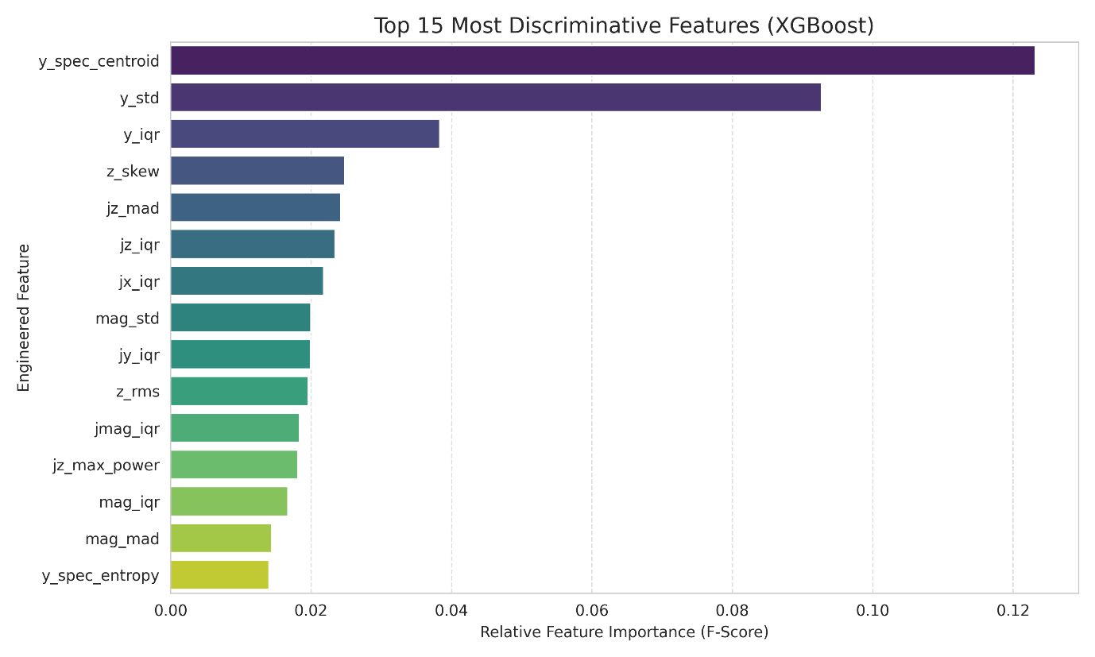
Figure 11: F-Score Feature Importances from the final XGBoost architecture, validating the necessity of frequency and derivative extraction.
Extracting the F-Score feature importances (Figure 11) clearly validated the methodological approach. The single most discriminative feature was y_spec_centroid (the spectral centroid of the vertical y-axis), overwhelmingly proving that the frequency of a user’s vertical foot-strike is the ultimate differentiator between dynamic activities. Furthermore, the dominance of Jerk derivatives (e.g. jz_mag, jz_iqr) confirms that calculating the rate of change of acceleration successfully bypassed the orientation bias that previously caused the deep learning models to fail.
Model Validation and Biomechanical Entanglement
Crucially, to simulate the Kaggle holdout set, we validated the model using a 9-fold GroupKFold strategy, grouping the splits strictly by user_id. The 140-feature XGBoost architecture yielded highly stable cross-validation metrics, achieving a final Group Out-Of-Fold (OOF) accuracy of 0.8729 (95% CI: [0.8204, 0.9254]).
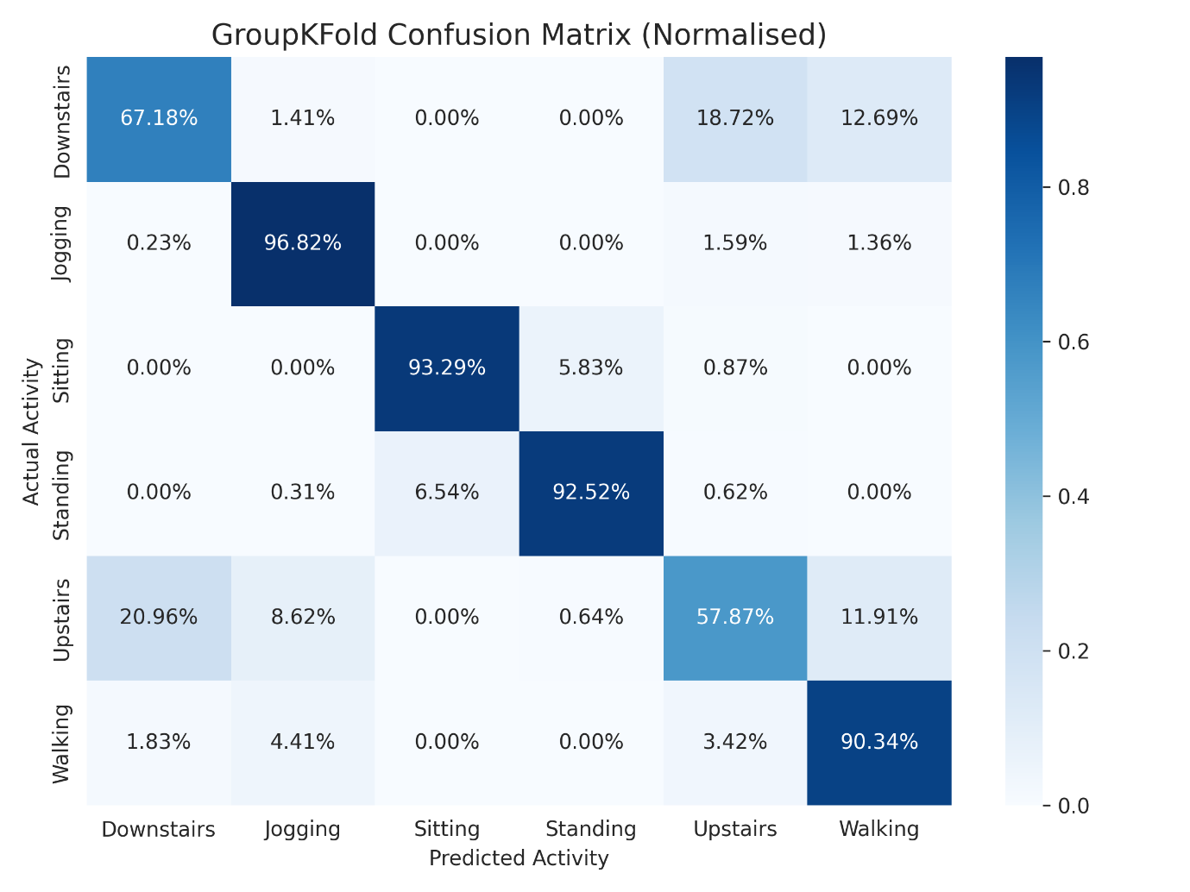
Figure 12: Normalised GroupKFold Confusion Matrix, demonstrating exceptional precision on foundational movements alongside expected biomechanical entanglement in stair navigation.
Analysing the normalised GroupKFold confusion matrix (Figure 12) provides a highly transparent view into the model’s biomechanical boundaries. The architecture demonstrates extraordinary precision on foundational movements, classifying Jogging (96.82%), Sitting (93.29%), Standing (95.52%) and Walking (90.34%) with near-perfect recall across entirely unseen users. The minor confusion between Sitting and Standing (~6%) is expected, as both are static postures governed purely by gravity, differentiated only by slight variations in pocket tilt.
The matrix reveals that most of the model’s error rate stems from a single, highly entangled class boundary: Upstairs and Downstairs. The model accurately predicts Downstairs 67.18% of the time and Upstairs 57.87% of the time, frequently confusing the two with each other (roughly 18-21% misclassification rate) or with standard Walking (~12%). This makes biomechanical sense, since ascending and descending stairs are essentially walking with added vertical displacement. The similarity in harmonic frequency and foot-strike impact makes them the hardest physical states to separate, even in a highly dimensional feature space. Acknowledging this limitation highlights the extreme difficulty of purely sensor-based Human Activity Recognition without secondary altitude data (such as a barometer).
The Generalisation Trap: Anomalous Sample Weighting
During the cross-validation diagnostics of the XGBoost architecture, we isolated a severe performance degradation in Fold 6. Forensic data analysis revealed that this collapse was driven by three specific subjects (Users 525, 954 and 3171) who exhibited extreme, chaotic variance in their vertical (y-axis) acceleration. Biomechanically, this suggested these users were carrying their devices loosely, in a bag for example, rather than securely in a pocket, introducing severe secondary bounce artefacts into the waveform.
To mitigate this, we engineered an experimental pipeline where we assigned a penalised sample weight of 0.3 to these specific users during model training. The idea was that mathematically down weighting this chaotic data would prevent the decision trees from overfitting to the noise, whilst still allowing the model to learn the underlying kinematic baselines.
However, while the 0.3 sample weighting successfully stabilised the local cross-validation variance for Fold 6, it actively degraded the model’s performance on Kaggle. This showed that artificially penalising “noisy” data inadvertently forces the model to overfit to “ideal” sensor conditions.
In real life, users will inevitably place their devices in loose pockets or bags. By instructing the model to ignore the chaotic waveforms of the training set, we stripped it of its ability to generalise to imperfect, high-variance environments. So, we removed the sample weighting mechanism from the final XGBoost architecture, intentionally allowing the model to train on the unpenalized, messy reality of human movement to preserve maximum robustness.
The Post-Processing Paradox: Stateless vs. Chronological Evaluation
We conducted a final experiment to apply a Temporal Smoothing filter (Rolling Mode) over the model’s continuous output probabilities. We were thinking that since human movement is contiguous, then mathematically smoothing brief, impossible physical transitions (e.g. Walking Sitting Walking over a 3-second span) would increase accuracy.
However, this resulted in a catastrophic Kaggle score collapse to 0.54665. The time-series sorting algorithm completely decoupled the predictions from the discrete, static row-order expected by the evaluation engine.
Ultimately, reverting to the discrete, heavily regularised XGBoost architecture yielded extraordinary results. The absolute difference between the Public Leaderboard score (0.92485) and the private Leaderboard score (0.92200) was a mere 0.00285, proving the model’s absolute statistical stability and supreme generalisation to unseen individuals.
Discussion of the Results
Reflection on Methodological Success and Feature Engineering
The primary triumph of this methodology lies in the empirical validation that domain-specific, physics-informed feature engineering is vastly superior to automated representation learning for this specific sensor dataset. The exploratory data analysis initially revealed severe waveform entanglement, leading to the hypothesis that deep learning (1D-CNN) could autonomously map the spatial hierarchies. However, the critical failure of the CNN (dropping to ~0.907 accuracy on unseen users) exposed the fragility of unanchored spatial models to orientation bias. By pivoting to deterministic feature extraction, the final architecture successfully bypassed this hardware limitation. Features such as the Signal Magnitude Area and Jerk derivatives provided rotation-invariant thresholds, while frequency-domain metrics (e.g. y_spec_centroid) successfully quantified the rhythmic harmonic cadence of human motion. Ingesting these 140 robust features into an XGBoost architecture, coupled with aggressive structural regularisation, effectively bridged the generalisation gap, achieving a highly stable Final Score of 0.920583837 in the previous 140-feature model.
Critical Evaluation of Model Failures (The Staircase Entanglement)
Despite the model’s exceptional precision on foundational movements (Walking, Jogging, Sitting, Standing), the confusion matrix (Figure 12) explicitly highlighted a persistent biomechanical blind spot: the entanglement of navigating stairs. The model frequently conflated ascending and descending stairs with one another (roughly an 18-21% error rate) and with standard walking (~12%). Critically reflecting on this limitation, it becomes evident that this is not an algorithmic failure, but rather a fundamental hardware constraint. Accelerometers solely measure kinetic force and displacement over time. Because the bipedal mechanics and foot-strike impacts of walking and stair navigation share nearly identical harmonic frequencies, they remain topologically entangled even after rigorous feature engineering. Without secondary sensors providing absolute spatial context, purely kinetic classification reaches a mathematical ceiling.
The Deployment Paradox and Real-World Applicability
Furthermore, the catastrophic failure of the temporal smoothing experiment provided a profound insight into the dichotomy between static evaluation frameworks and real-world deployment. The Kaggle testing environment evaluates snippets as stateless, independent rows. However, human movement is inherently contiguous. While chronological smoothing failed the Kaggle evaluation criteria, incorporating a Hidden Markov Model (HMM) or a rolling-mode filter over continuous output probabilities would be highly effective in a real-world, streaming deployment to eliminate impossible physical transitions (e.g. sprinting directly into a seated position in under a second).
Insights and Suggestions for Future Work
To push beyond and resolve the limitations identified in this study, future iterations should focus on sensor fusion and hybrid architectures. Firstly, integrating gyroscopic data (measuring angular velocity) and barometric altimeter data (measuring atmospheric pressure) would instantly resolve the Upstairs/Downstairs entanglement by tracking vertical elevation changes. Secondly, future architectures could explore Hybrid Transformer models. Rather than relying entirely on manual feature extraction or raw wave inputs, a hybrid approach could feed the 140 deterministic features into a temporal attention mechanism, allowing the model to weigh the importance of specific physical traits dynamically across different time windows. Finally, implementing a brief “user-calibration” protocol, where a user stands still for five seconds before initiating the activity, would establish a baseline gravity vector, entirely eradicating orientation bias and allowing more complex spatial deep learning models to be safely deployed.

